
Bulgarian Federation of Radio Amateurs

12th IARU Region 1 Youth ARDF Championships
16-19 JUNE 2011

In conjunction with Four Days ARDF at Bulgarian Black Sea Coast, Primorsko, 12- 15 JUNE 2011, now named BLACK SEA ARDF TOURNAMENT

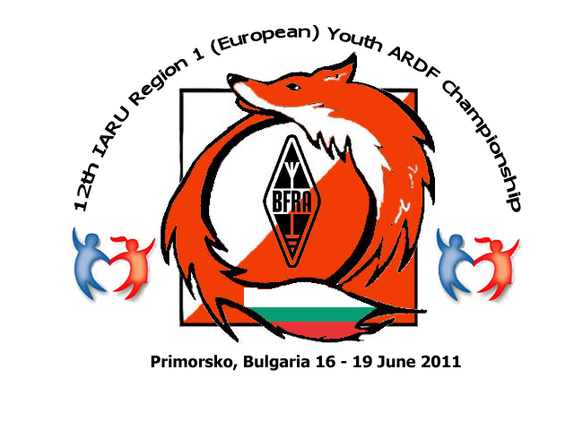
Bulletin 3
30 April 2011
Information for participants

Accommodation:
Perla Sun Park Hotel****, Primorsko
http://www.perla-tourist.com/component/option,com_estateagent/Itemid,46/act,object/task,showEO/id,12/
Accommodation in hotel rooms (3 persons) or apartments (4 persons).

Driving direction:
Enter Primorsko, at first traffic light turn right (Saedinenie Street) and drive 500 m straight to find the hotel on left side (9-store building). GPS coordinates: 42.263163 N, 27.750789 E. See also: http://maps.google.bg/maps?hl=bg&ie=UTF8&ll=42.263163,27.750789&spn=0.001018,0.002564&t=h&z=19
Additional information about prices and payment:
Important note: Because of the holydays in the end of April and beginning of May, BFRA has decided to prolong the term for bank transfers till 5th May 2011.

Examples for costs:
Participation in EYAC: 150/165 EUR (paid till or after 5th May 2011);
Extra days before/after EYAC: 20 EUR per person per day;
Participation in Black Sea Tournament: 80 EUR;
Participation in both Black Sea and EYAC: 230/245 EUR;
Visitors of both events (non-officials, non-competitors): 160 EUR;
Starting fee for non-competitors, both days, running for fun, starting time 45 minutes after the last official start: Officials – free, Visitors – 7 EUR per day;
Single occupation hotel room: plus 20 EUR per night;

For your convenience – once again BFRA account details:

Beneficiary: Bulgarian Federation of Radio Amateurs Account in: EURO
Bank: United Bulgarian Bank IBAN: BG81UBBS80021413582613 BIC: UBBSBGSF

Maps: A4 format, Scale 1:10000, Sample bellow:
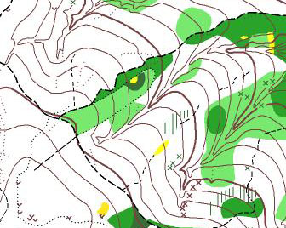
Transfers from Burgas, Varna and Sofia and back:
Please contact the organizers at bfra_hq@hotmail.com and apply for the relevant transfer.
Prices vary depending on the number of passengers and approximately are: Burgas 15-20 EUR per person, Varna 20-30 EUR per person, Sofia – to be contracted.

Please, inform us about your accommodation and traveling details, fulfilling and sending us the table bellow:

RoomApart-ment | Name, Family name |  |  | Passport No |  | Category (M14, W14, M16, W16, Official, Visitor)
1
2
3
4
5
6
Please mark with X the proper one:
Arrival with own bus/car(s): |  |  | Date:
Arrival by air: |  |  | Date:
Time: |  | Airport: | Flight Number: |  | From:
Arrival by train: |  |  | Date:
Time: |  | Train station: | From:

Send the above table as soon as possible to: bfra_hq@hotmail.com
All the details for the 12th EYAC can be found in Bulletin 1 and Bulletin 2 in http://www.eyac2011.eu/
Telephones for contacts:
Daniel Nikolov: +359888619195
Victor Tzenkov: +359889318297
Everybody is welcome. We are looking forward to meeting you in Primorsko!

