16th R1 IARU
Youth
ARDF Championship
04 – 08 June 2015 Zamość
Poland

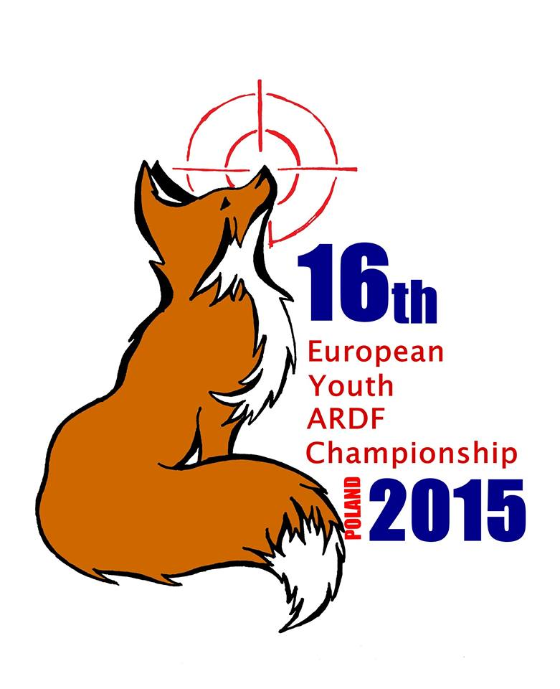

.
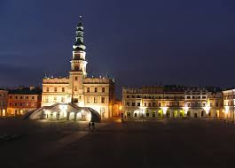
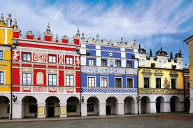
Dear Friends
Polish Amateur Radio Union (PZK) and Zamość Council have pleasure to invite competitors and members of I Region IARU for 16th European Youth ARDF Championship , which will be held in Zamość . We will be pleased to welcome and host you in our city known as the Padua of the North and the Pearl of The Renaissance located nearby picturesque Roztocze Region and National Park.

Programme of the Championships

4.06.2015 Thursday
Arrival
Training on KF, UKF
Opening Ceremony
5.06.2015 Friday
Classic competition UKF
Sightseeing trip
Awarding Ceremony
6.06.2015 Saturday
Sprint competition KF
Awarding Ceremony
7.06 .2015 Sunday
Classic competition KF
Awarding Ceremony
Closing Ceremony and banquet
8.06. 2015 Monday
Departure

Detailed information In www.eyac2015.ardf.ofr.pl
Contacts:
e-mail: sp2jmr@pzk.org.pl

Venue
Poland
Zamość
Voivodship Lubelskie
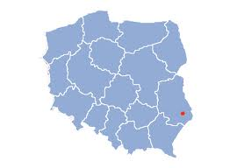

How to Reach us

- by train from Kraków, Warszawa, Lublin
- by plane to Warszawa, Kraków, Rzeszów, Lublin then by bus or coach to Zamość

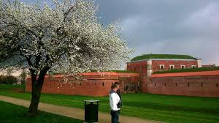

Distances from main cites and international airports :

Świdnik near Lublin 75 km
Rzeszów 161 km
Warszawa 257 km
Kraków 300 km
Katowice 400 km
Lwów ( Ukraine ) 130 km

The Total cost of participation max. 220 euro
Specific costs bulletin no. 2 in December

